Down Syndrome Association of Greater Winston-Salem  4715 Yadkinville Rd., Winston-Salem, NC 27040 | 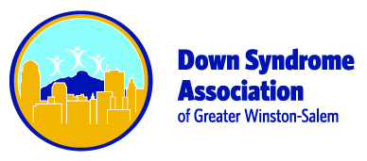

Date | To
Instructions
Please make checks payable to PDSSN or DSAGWS.
Quantity | Description | Unit Price | Total
 |  | Subtotal
 |  | Sales Tax
 |  | Shipping & Handling
 |  | Total Due
Thank you for your business!

